25.71: a) With an ammeter in the circuit:
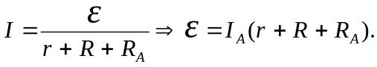
So with no ammeter:
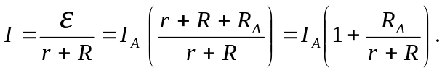
b) We want:
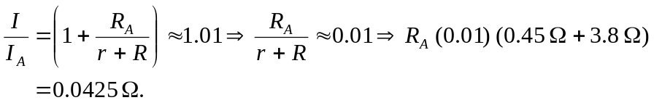
c) This is a maximum value, since any larger resistance makes the current even less that it would be without it. That is, since the ammeter is in series, ANY resistance it has increases the circuit resistance and makes the reading less accurate.

